# Toy Data Set

Diabetes data set (<https://scikit-learn.org/stable/datasets/toy_dataset.html>) (7.1.2)

442 samples; 10 features (described below) along with target value.

Features are scaled by mean and std deviation; no null entries or wrong data.

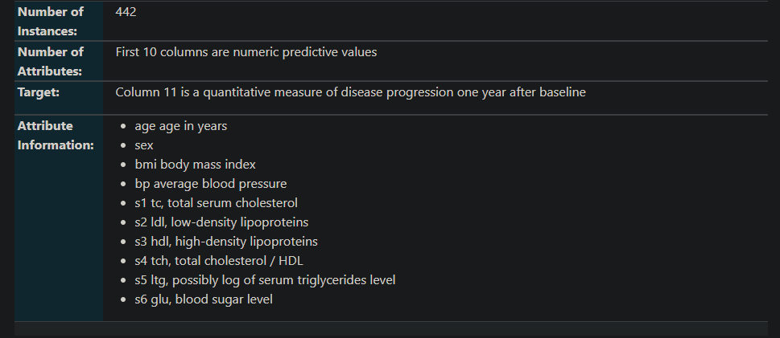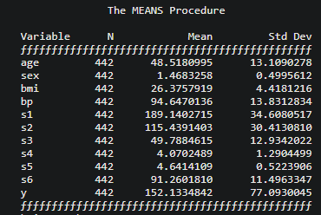

# Model Training

Standard training parameters used.

70% used as training data, 30% as testing data.

Model saved using pickle.

Saved as ‘model.pkl’

# Flask Deployment

app.py (scale factors are from the MEANS approach above – hard coded here since they are constant)

Index.html and style.css modified from <https://www.w3docs.com/learn-html/html-form-templates.html> (free to copy and use)

CSS: <https://github.com/farischaudhry/heroku-demo/blob/master/static/css/style.css>

HTML: <https://github.com/farischaudhry/heroku-demo/blob/master/templates/index.html>

# Final Product

2 decimal places allowed in entries.

Units specified for blood test results.

Sex has dropdown list for male and female.

All entries are set to required.

Regression value is showed in bottom-right corner (higher value means disease likely to be further progressed one year from now).

